June 01, 2018

Subject: Requirement for California Proposition 65 Warning. Your response is required.

Dear Authorized Retailer/Reseller Agent:

In compliance with Title 27 California Code of Regulation; Article 6 Clear and Reasonable Warning, please be advised that the 841 Super Shield Nickel Conductive Coating may lead to exposure to Proposition 65 listed chemicals.

The concerned product names and catalog numbers with listed chemicals are provided in Table 1, which also includes the warning that must be provided to your customers through labels, signs or on Web postings. Currently, MG Chemicals already provides Prop 65 warning using the on-product label.

As per Section 25249.6 of the Act, you (the retail reseller) are responsible for the placement or maintenance of warning materials and providing the warning for products sold on the internet.

Table 1. Your MG products containing a Prop 65 listed chemical and their required warnings.
MG Part Number | Product  Name | Carcinogenic  Toxicants | Reproductive Toxicants
841-900ML | Super Shield Nickel Conductive Coating | Silica, crystalline (airborne particles of respirable size), Nickel (metallic) | toluene,  N-methylpyrrolidone
841-1G | " | " | "
California Proposition 65 warning required for signs and on product Web pages
WARNING | This product can expose you to chemicals including Silica, crystalline (airborne particles of respirable size) and Nickel (metallic), which are known to the State of California to cause cancer, and toluene and  N-methylpyrrolidone, which are known to the State of California to cause birth defects or other reproductive harm. For more information  go to www.P65Warnings.ca.gov.
Pre-existing, on product warning on the MG Chemicals Label
WARNING Cancer and Reproductive Harm—www.P65Warnings.ca.gov.

ATTENTION! The Title 27 California Code Regulation requires that you send an electronic or written confirmation that you have received this notice.

- Fill the empty acknowledgement fields provided in Table 2.
  - Write your business name.
  - Print the name of the retail or reseller representative and sign the copy.
  - Write your job title.
  - Write the date of signature.
- Return the completed document by email to sales@mgchemicals.com or
by fax to +1-800-340-0773.

Table 2. Acknowledgement of Notice Reception by Retailer for MG 841 Super Shield Nickel Conductive Coating
Retailer Name:

Acknowledgment Declaration: | I acknowledge receipt of the Prop 65 warning notice for the products listed in Table 1.
Print Name of Acknowledger:
Signature:

Job Title:

Date:

If you have any questions with regards to this notification, please contact us.

Best Regards,

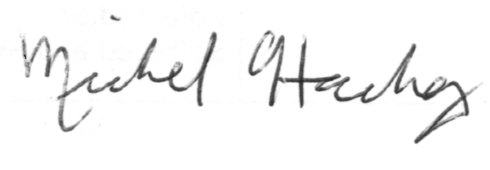
Michel Hachey, Ph.D.
Regulatory and Scientific Affairs Manager
MG Chemicals
1210 Corporate Drive
Burlington, Ontario L7L 5R6
Canada

Phone: 1-905-331-1396 Ext 1027
Toll Free: 1-800-340-0772 Ext 1027
Fax: 1-800-340-0773

